Summer bridging work
Product design Year 12
Students need to have a A5 sketch book filled with pictures and annotation of the exhibitions they have seen and articles on any aspect of design they have read over the summer.
This work is essential for students who want to apply to University courses after their A Levels.
Science Museum 12 June 2019-October 2020
Driverless: Who Is In control?
By handing over control of our cars to machines, we could save thousands of lives a year — but can we really trust machines to drive us everywhere? Science Museum has roped in some of the tech that's already showing us the future, including the remotely operated submarine Boaty McBoatface. Are we heading for a future where our food and parcels will be delivered by drones, and what are the consequences of this? Find out in this free exhibition.
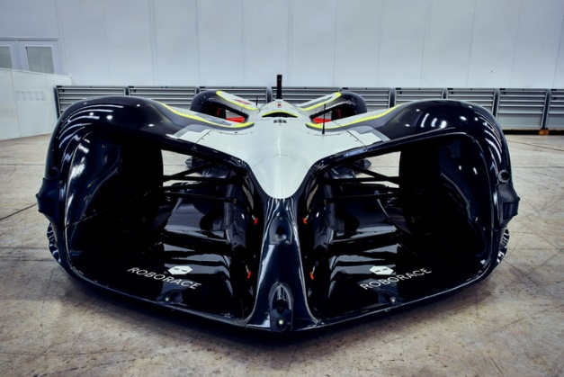

Pavilion in the Park

Serpentine Pavilion 2019 designed by Junya Ishigami. 21 June-6 October 2019, free.
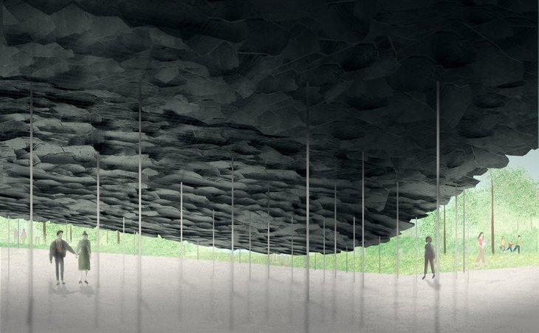
That's right people, we've got two outdoor pavilions this month — London, you're really spoiling us. Summer stalwart Serpentine Pavilion is back, and this time the architect in charge is Junya Ishigami. A slate structure emerges from the ground to create a cave like refuge, perfect for some contemplative time away from the bustle of the city or shelter from a summer rain shower.

A day in your life.
Take a picture every 15 minutes of what you are doing for the whole day. Load pictures into a Power point presentation.
Present to the class in September.

