A Level Dance
At KAA
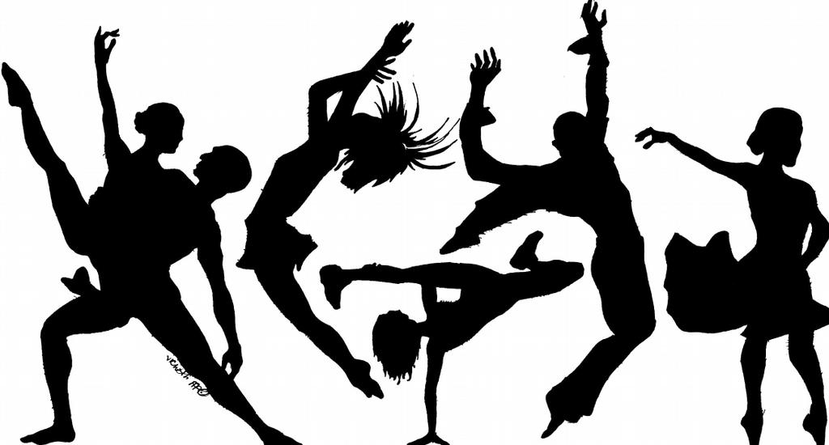

Name:..............................................................................

A Level Dance- Course Overview

The study of dance enables you to develop socially whilst promoting creativity, fitness and well-being. As well as developing as performers, you’ll also develop skills in confidence, self-esteem and team working skills.
Assessment includes a combination of practical dance tasks alongside creative extended writing assignments. This will equip you with the necessary skills and experience to study dance further, or embark on an exciting career in the arts.

A Level
Component 1  Performance and Choreography  80 marks  50% of A Level | Solo performance linked to a specified practitioner  Students must perform as a soloist in the style of a specified practitioner. The practitioner must be selected from the choreographer of one of the prescribed set works located within an area of study or a named practitioner within one of the prescribed areas of study.  Performance in a quartet  Students must learn how to perform as part of a quartet. The quartet performance can be choreographed by the student, their teacher or a dance artist. The dance can be performed in any dance style.  Choreography  Students must create an original piece of group choreography, which lasts for a minimum of three minutes to a maximum of four minutes, for three, four or five dancers, in response to an externally set task based on a stimulus.
Component 2  Critical Engagement  100 marks  50% of A Level | Written paper (2 hours 30 minutes)  Students must show knowledge, understanding and critical appreciation of two set works within the two areas of study.  - Rambert Dance Company (1966-2002)  - Set work: ‘Rooster’ by Christopher Bruce  - American Jazz Dance (1940-1975)  - Set work: ‘Singin’ in the Rain’ by Gene Kelly and Stanley Donan

Choreographic Task
As A Level Dance students you will need to be able to show you have a clear and developed understanding of the idea, leading to highly imaginative and creative outcomes in your choreographies. This will be achieved though effective and informative research, so that you are able to see beyond the simple and obvious choices.
Over the Summer I would like you to research one of the following ideas as a stimulus to create a piece of solo choreography.
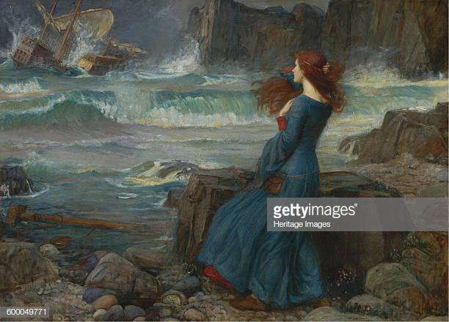
- Choreograph and perform a dance based on an exploration of the painting ‘Miranda, The Tempest’ by John William Waterhouse (1916).

- Choreograph and perform a dance based on an exploration of the symbolism associated with one animal of your choice. This excludes the study of ‘humans’.

- Choreograph and perform a dance based on an exploration of ‘point’ and ‘line’ as defined by Wassily Kandinsky (1866–1944) in his teaching.
Task 1:
- Create a short motif of movement that clearly shows the idea you are expressing in your choreography.
- The motif must be at least 32 counts in length and consist of appropriate actions, dynamics and spatial ideas which relate to the stimulus.
Task 2:
- Create a presentation with accompanying notes on how you would choreograph a solo dance based on the idea you have chosen, you will need to consider the following:
  - How you have interpreted the idea/what aspect of it you are portraying
  - Choice of actions, dynamics, spatial patterns and reasoning for this
  - Structure of the dance
  - Choice of music

Practitioner Research
Chose a practitioner from one of the areas of study at A Level Dance and create an A4 length fact file on documenting the following information:
Practitioners:
Glen Tetley (1926-2007)
Robert North (Born 1945)
Christopher Bruce (Born 1945)
Richard Alston (Born 1948)
Jerome Robbins (1918-1998)
Bob Fosse (1927-1987)
Gene Kelly (1912-1996)

- Background information
- Influences (on themselves/on others)
- Choreographic style
- Movement style
- List of work created
- Affiliations with Dance Companies

Keeping Active
Look at the genres of dance used in the AQA A Level Dance specification and pick which one you feel you have the least experience in.
During the summer take part in a class or workshop for this genre to enhance and broaden your skills in the style. You will need to write a short summary of the session including information about the class/workshop you took part in as well as what you learnt from it.
Below is a list of links to available classes and workshops across London which might be worth attending:
https://www.pineapple.uk.com/
http://www.rambert.org.uk/join-in/
http://www.theplace.org.uk/summer-dance-courses-2016
http://www.trinitylaban.ac.uk/take-part
Reading List
Below is a list of books which may be useful to your study throughout the A Level Dance course. There is no obligation to buy or read all of these but pre reading about your subject will definitely help you throughout the course.
Compulsory Area of Study: Rambert Dance Company (formerly Ballet Rambert) 1966 – 2002
- Bremser, M. and Sanders, L. (eds). (2011). Fifty Contemporary Choreographers. 2nd edition. London: Routledge
- Clarke, M. and Crisp, C. (1989) London Contemporary Dance Theatre: the first 21 Years. London: Dance Books
- Crisp, C., Sainsbury, A. and Williams, P. (eds). Ballet Rambert, Fifty Years and On. London: Rambert Dance Company
- Dance Study Supplement Part One: Contemporary Dance available from the Dancing Times
Optional Area of Study: American Jazz Dance 1940-1975
- Conrad, C. (2000) Jerome Robbins that broadway man that ballet man London: Booth-Clibborn Editions
- Emmet Long, R. (2001) Broadway, The Golden Years. Jerome Robbins and the Great Choreographers 1940 to the present New York, London: Continuum
- Hirschhorn, C. (1975, 1984) Gene Kelly: A Biography Chicago, Regnery, New York: St Martin’s Press
- Parkinson, D. (2007) The Rough Guide to Film Musicals London: Rough Guides Ltd
All tasks will be due in on the first lesson back, if you have any questions about the course or tasks please don’t hesitate to contact me on r.dunning@kaa.org.uk

